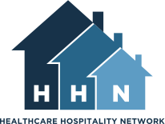

NATIONAL HEALTHCARE HOSPITALITY WEEK

SOCIAL MEDIA TOOL KIT

Updated June 2025
For more information: www.hhnetwork.org
info@hhnetwork.org

SOCIAL MEDIA TOOL KIT

Contents:

- Using your website
- Social Media
- Leveraging online donations
- Share your experience

PREFACE
Every year HHN Members throughout North America provide vital support services to communities by welcoming thousands of patients and caregivers into their homes. Join HHN for National Healthcare Hospitality Week, recognizing the leadership role of hospitality houses in providing this essential support service.

This Social Media Toolkit is an excellent guide to utilizing social media opportunities. Not limited to National Hospitality House Week, this Social Media Toolkit offers tips, suggestions and instructions that can be used at any time to assist in promoting your houses, events, and activities.

USING YOUR WEBSITE

When someone is interested in finding out more about your organization, what is the first thing they do? A quick Google search should give any potential volunteer, donor, or guest the who, what, when, and why about any event your organization is planning.

For this reason, your first stop in social media marketing should be creating a place for Hospitality House Week on your organization’s website.

CALENDAR
You can keep it as simple as updating your website’s calendar to reflect your Hospitality House Week scheduled activities. Be sure to include a place to RSVP if you require advanced registration. There are many websites that will collect RSVPs for you, including Eventbrite, JotForm, and Google Forms.

Facebook events can also be a great way to leverage social media to get the word out. Make events specific: “Tours and Root Beer Floats, Tuesday from 1pm-4pm” rather than general: “Hospitality House Week at Hope Lodge!” This will give people concrete information and a place to be, rather than a general show of support.

WEBSITE PAGE
The best way to aggregate all your information and clearly explain National Hospitality House Week is creating a page on your website dedicated to NHHW exclusively. All your activities for the week can be in one place with proper contact information. If you have a need for volunteers, you can ask. If you have a media kit ready to go, you can provide a link. If you have event sponsors, be sure to list them or include their logo. Set your site to something simple, and hyperlink when sending out. For example, HHN NHHW .

Share this page with your community every time you mention Hospitality House Week in newsletters, on social media, or in email. Imagine it as your main information hub for anyone who asks about NHHW or any of your activities for the week. Inquiries should be directed to your well thought out, easy to navigate hub.

LOGO’S
Remember to include HHN’s logo as a clickable link so visitors to the page can visit HHN’s website as well. This will help lend credibility to your events. Many of your social media posts will mention Hospitality House Week briefly with no explanation, so branding your page with Hospitality House Week information will help viewers learn more and receive the big picture of your work.
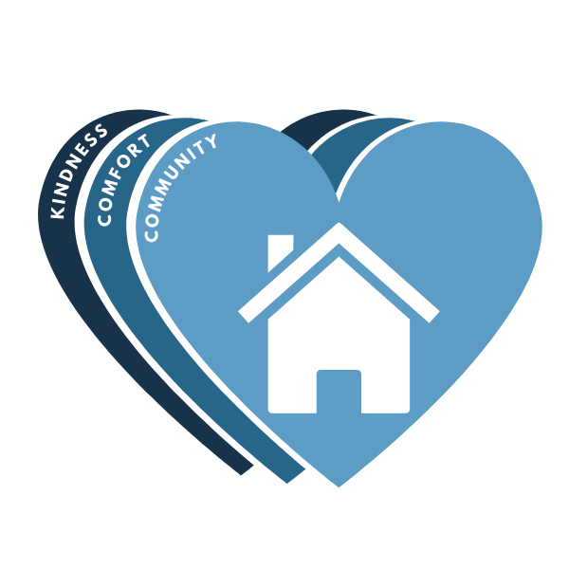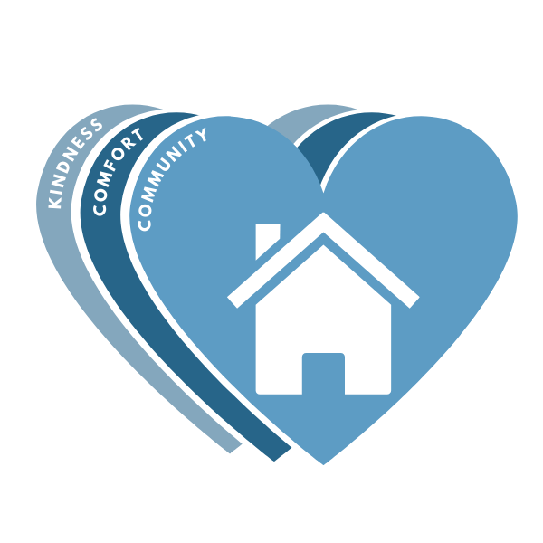

BANNER AND FRONT PAGE
When people visit your website, they may spend as little as 30 seconds finding the key information they need: a phone number, address, or contact email. Leverage the time they spend on your webpage by including information about National Hospitality House Week front and center on your page in the form of a banner. Always ensure the banner and any text links back to your Hospitality House Week page.

NHHW Banner:

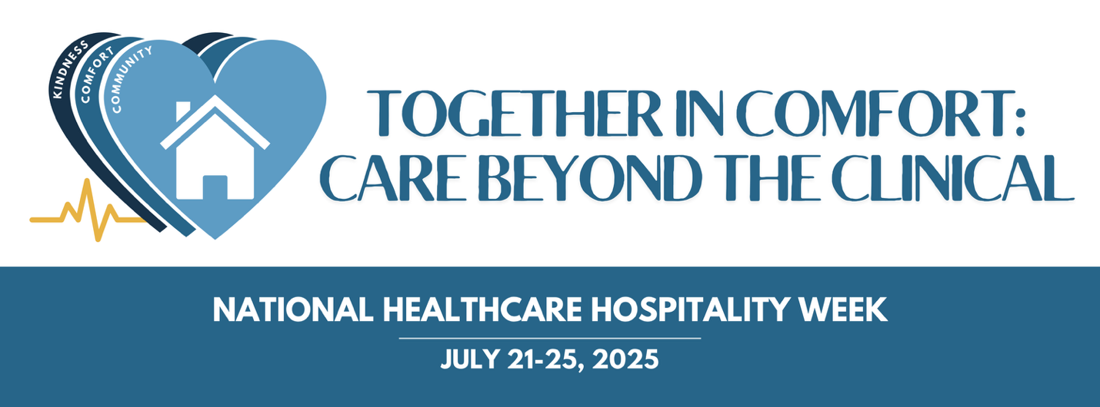

SOCIAL MEDIA INTERACTION

Social media can be wonderful tools for promoting events and showcasing the fruits of your labor. Here are some frequently asked questions (FAQs) to help you navigate event promotion on social media:

Which social media platforms should I use to promote my event?
The best platforms for promoting your event depend on your target audience. Commonly used platforms include Facebook, Instagram, Twitter, and LinkedIn. Facebook is great for creating event pages and engaging with a broad audience, while Instagram is perfect for visually appealing content. Twitter is useful for real-time updates, and LinkedIn is ideal for professional events.

How often should I post about National Healthcare Hospitality Week?
Leading up to Hospitality House Week, share your webpage and a photo of your banner. Set the banner as your website's Facebook cover photo for even more impact! Reuse materials such as photos, graphics, and wording in multiple places.

Photos are a safe bet as they are easily shared and can visually represent your work. Ask volunteers to create a graphic of your agenda for the week. Take photos of volunteers distributing flyers at the hospital. Your social media connections want to feel included and see the behind-the-scenes action that sets you apart from other pages they follow.

What should I post before Hospitality House Week?
Post photos, quotes from guests, and event invitations to spread the word about your activities. Show behind-the-scenes action. Always include a consistent call-to-action link. This will guide people to RSVP, register, learn more, or even donate!

What to Post During Hospitality House Week?
Showcase the successes and highlights of Hospitality House Week to your followers, ensuring they see the impact of your efforts. Remember to include the HHN National Healthcare Hospitality IMPACT Graphics and tag HHN in all posts.
Here are some tips on what to post:

DAILY HIGHLIGHTS:
- Photos and Videos: Capture and share moments from each day's events. Designate a photographer, either using a cell phone or a hobby photographer from your volunteer pool or community for high-quality shots.
- Event Summaries: Post brief summaries of the day's activities and key highlights. This could include notable speeches, performances, or milestones achieved.

BEHIND-THE-SCENES CONTENT:
- Preparation Moments: Show the effort behind organizing the events. Share behind-the-scenes photos and videos of your team setting up, volunteers in action, and special preparations.
- Volunteer Spotlights: Highlight the contributions of your volunteers by sharing their stories and why they are passionate about supporting Hospitality House Week.

TESTIMONIALS AND SUCCESS STORIES:
- Guest Testimonials: Share quotes or short video testimonials from guests who have benefited from your services. Their personal stories can be very impactful.
- Success Stories: Post updates on the positive outcomes and successes achieved through your programs, including before-and-after stories or milestones reached during the week.

INTERACTIVE CONTENT:
- Live Streams: Host live streams of key events or activities, allowing followers to join and feel part of the event, even if they can't attend in person.
- Polls and Q&A Sessions: Engage your audience by posting polls or hosting live Q&A sessions, encouraging interaction and increasing engagement.

CALL-TO-ACTION:
- Donation Appeals: Remind your followers how they can support your cause. Include links to your donation page and explain how their contributions make a difference.
- Event Invitations: Encourage people to join upcoming events or activities throughout the week. Provide details on how to participate.
RECAP AND THANK YOU POSTS:
- Daily Recap: Post a recap at the end of each day, highlighting key moments and thanking participants.
- Final Thank You: Post a comprehensive thank you message at the end of the week to all supporters, volunteers, and participants. Highlight the overall success and impact of Hospitality House Week.

FREQUENCY AND TIMING:
- Consistency: Upload photos and updates frequently, preferably at least one or two posts every day, to maintain buzz and drive people to your website or donation site.
- Optimal Times: Post during times when your audience is most active on social media, typically in the morning and evening.

NEED INSPIRATION?
Don't reinvent the wheel! Not sure what to post? We have included text ideas for you with each National Healthcare Hospitality IMPACT graphic. By sharing engaging and varied content throughout Hospitality House Week, you can keep your followers informed, inspired, and involved, ultimately driving more support and participation.

LEVERAGING ONLINE DONATIONS

There are many options for online giving sites and many ways to leverage online giving throughout the year. Hospitality House Week may be a time when you are getting more attention than usual, and having a simple way to direct new people to give can be very beneficial to you and your donor base! Here are some best practices for leveraging online giving during Hospitality House Week:

CHOOSE A DONOR PLATFORM YOU LOVE
Some popular platforms are MightyCause, PayPal, Bloomerang, GivingFuel, and OneCause. Customize your chosen platform to tell YOUR best stories.

CREATE A STANDOUT DONATION LINK
Place a simple, standout link to give on your Hospitality House Week webpage. Use a color that stands out from the rest of the page. Consider using an online button generator to create an eye-catching button. Every time someone visits your high-traffic Hospitality House Week page, they will have the option to give.

ASK FOR DONATIONS MORE THAN ONCE A YEAR
Many nonprofits ask for gifts at the end of the calendar year. July marks an excellent point in the year to ask again. If you are not asking at least twice a year, you could be missing potential donors who are either too extended around the holidays or simply too busy. Don’t let your donors think you only need them around December when you need their support year-round. Hospitality House Week can be a great time to ask existing donors for their support and engage new donors.

SHARE YOUR EXPERIENCE

Tell us about your National Hospitality House Week! What went well? What didn’t work as anticipated? What would you do again? What would you do differently? Did you use these tips and suggestions for other events, activities or promotions of your house?

Let us share your successes!

Healthcare Hospitality Network exists to provide support to our members. Your samples, pictures, and results are deeply valued and will become an integral part of HHN’s Member Resources.

To share your information, email us: info@hhnetwork.org

